Amazon Webservice

1. Create Users:

IAM->

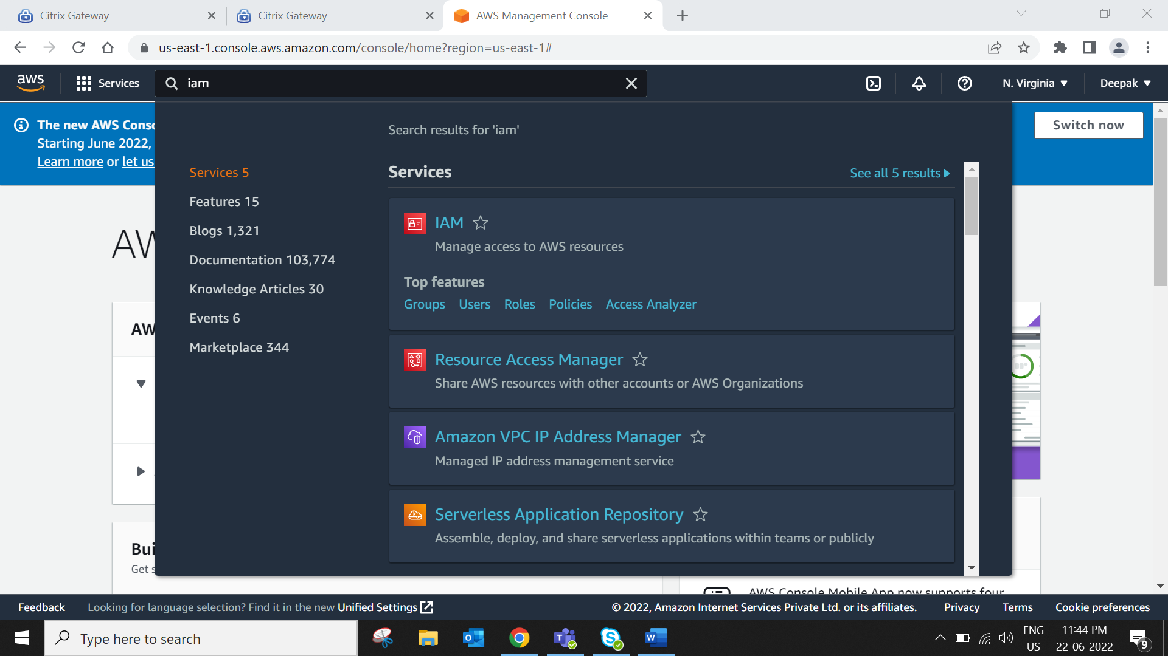  
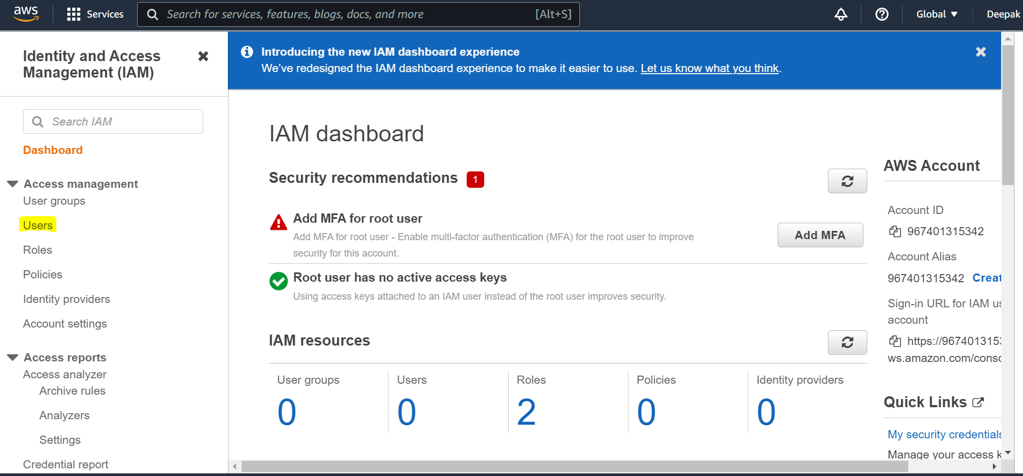  
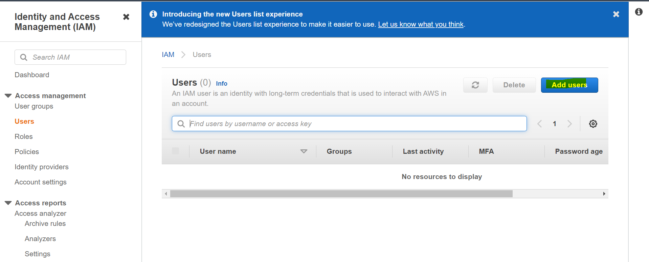  
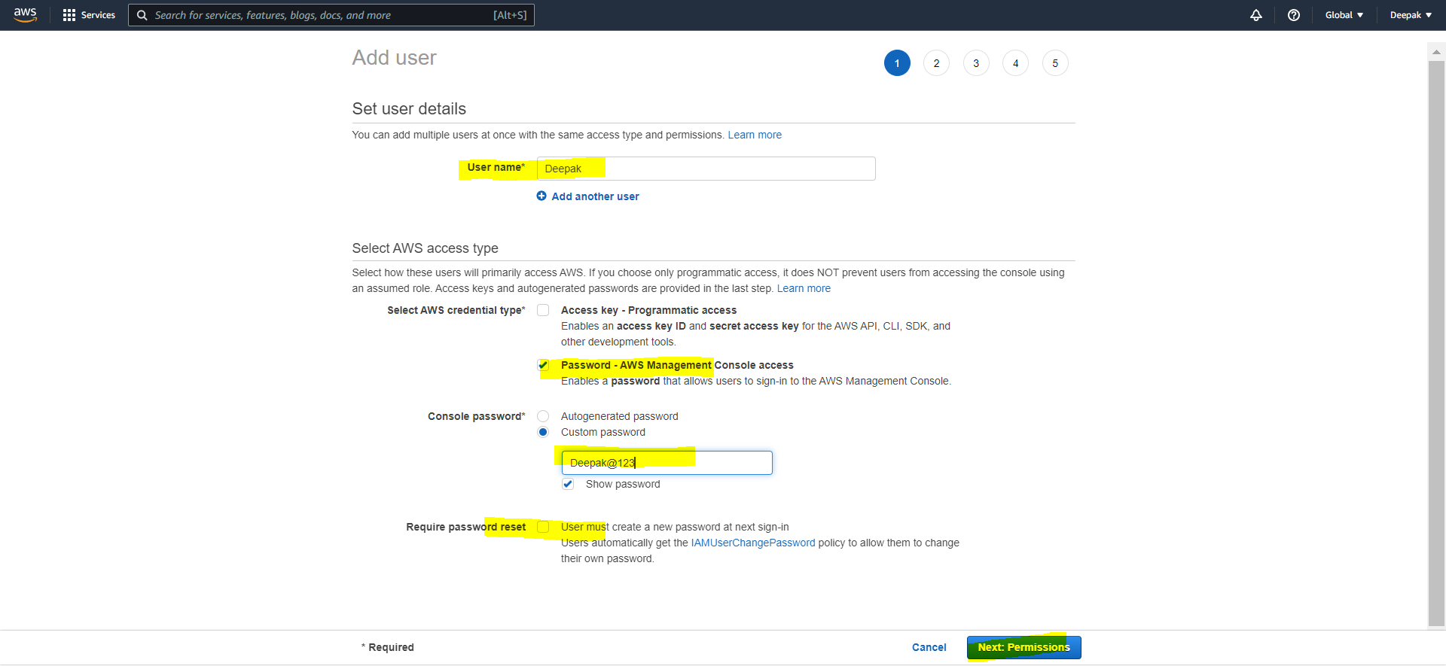  
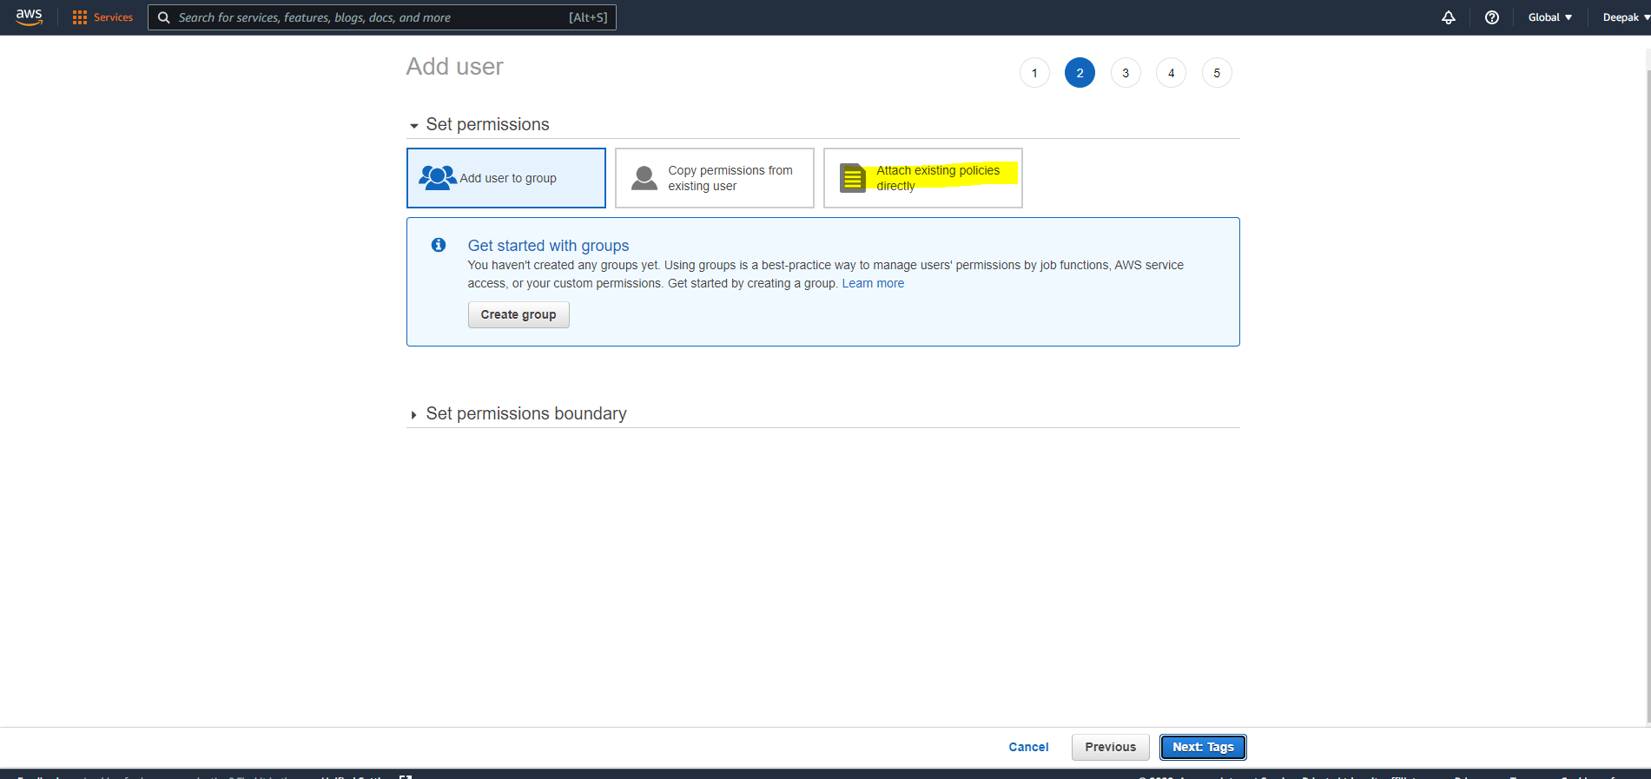  
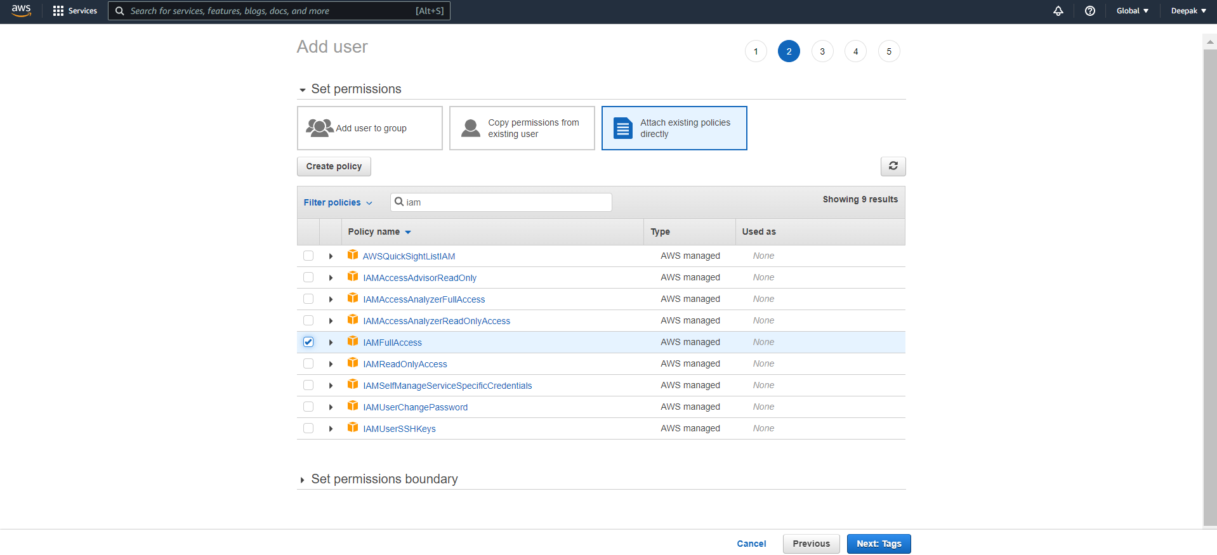  
If you are using IAM full access then user can create one more new user and if IAM read access is there then he can monitor the access.  
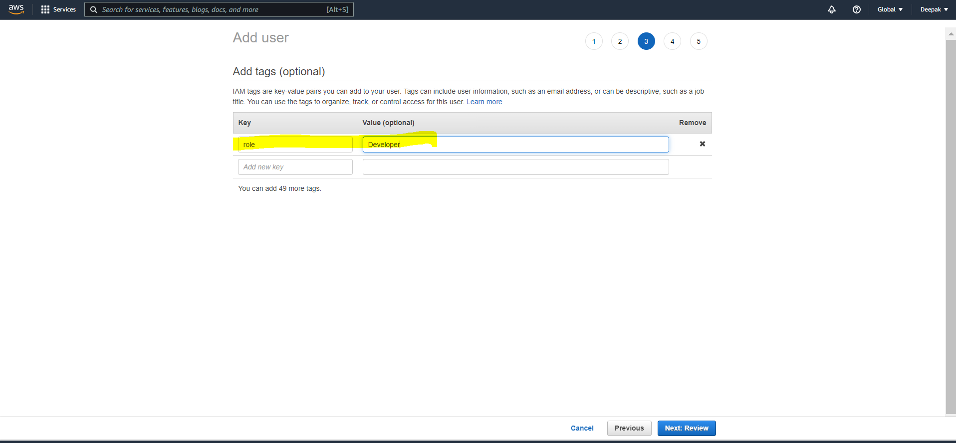  
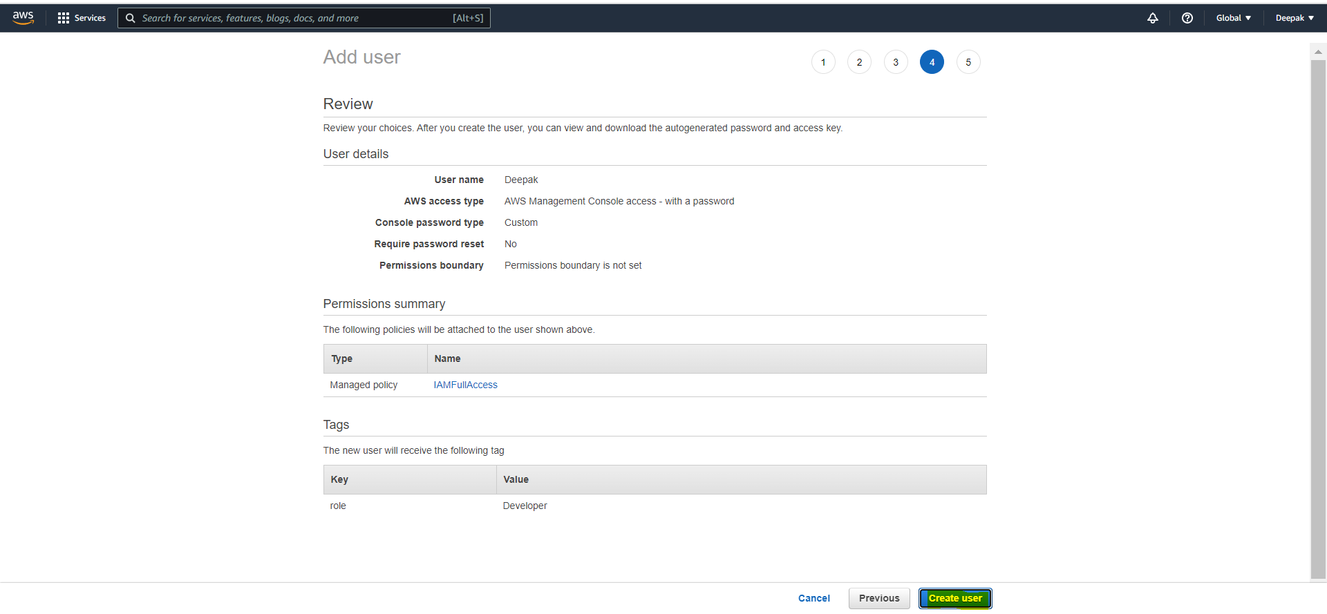  
  
How to login this account  
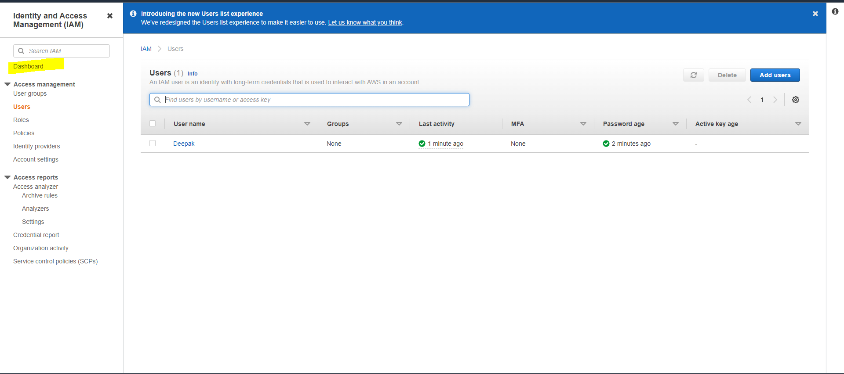  
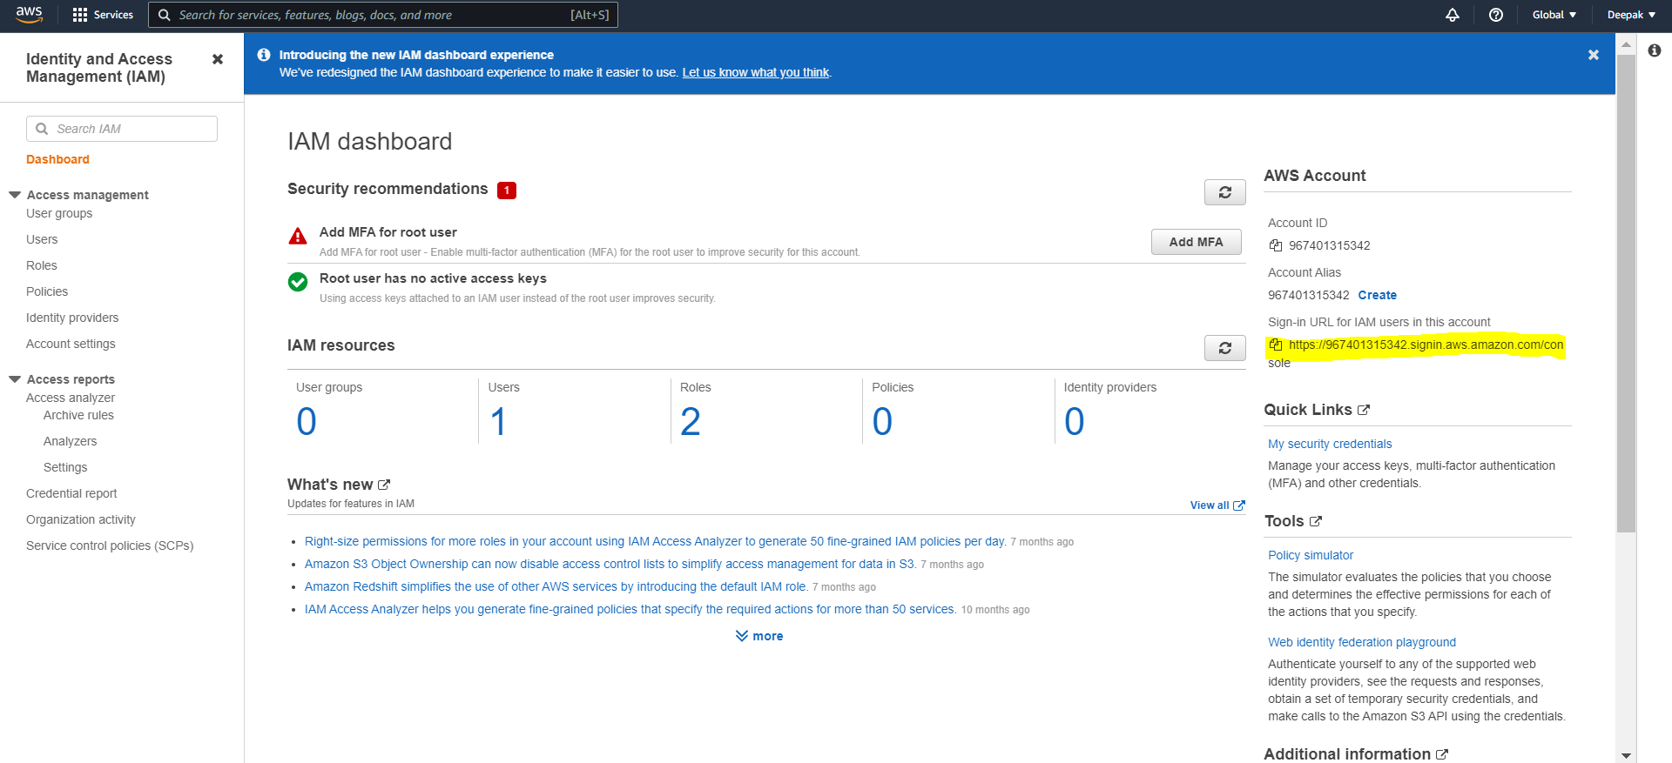  
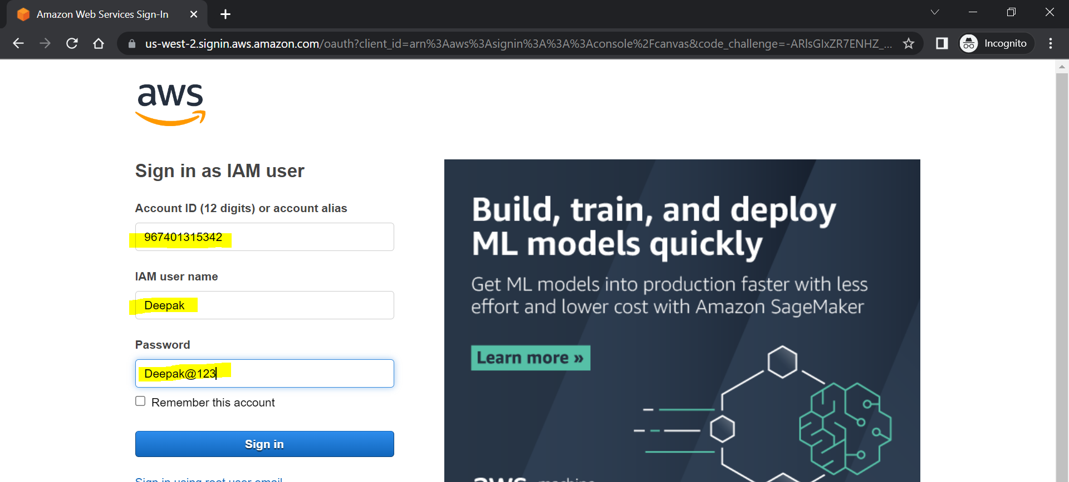  
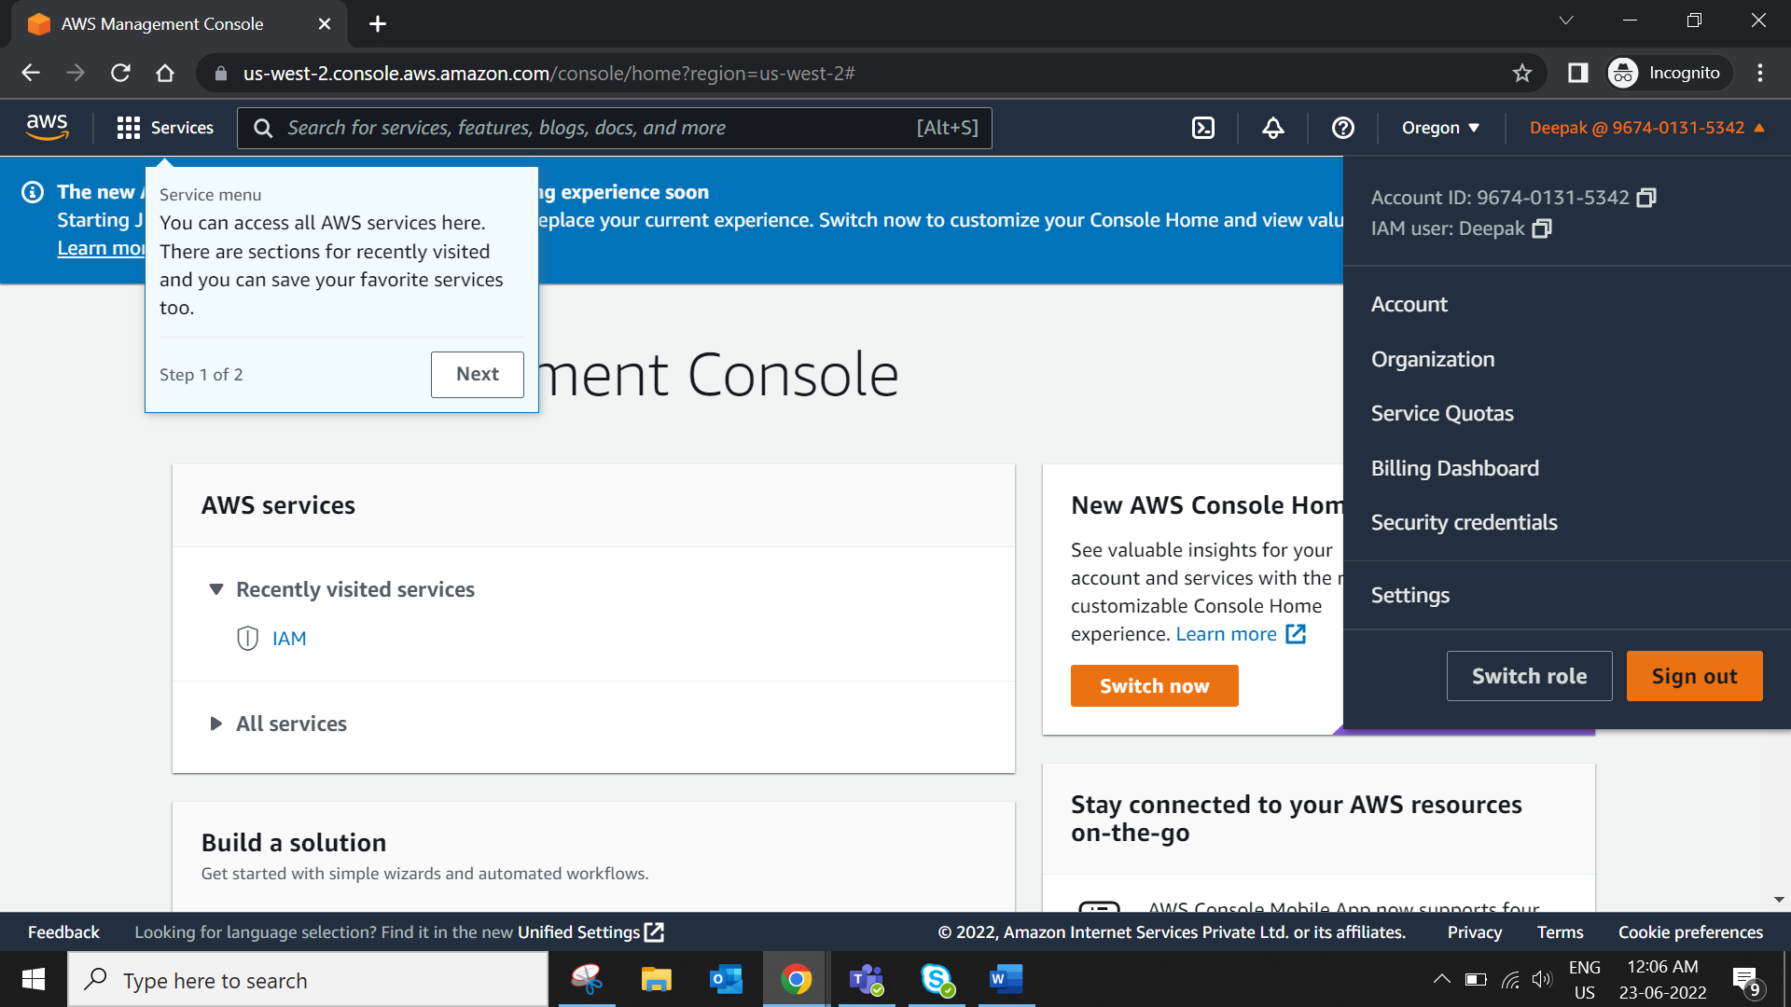  
Similarly you can create users assign policy add him in a group etc check access report analysis the same…  
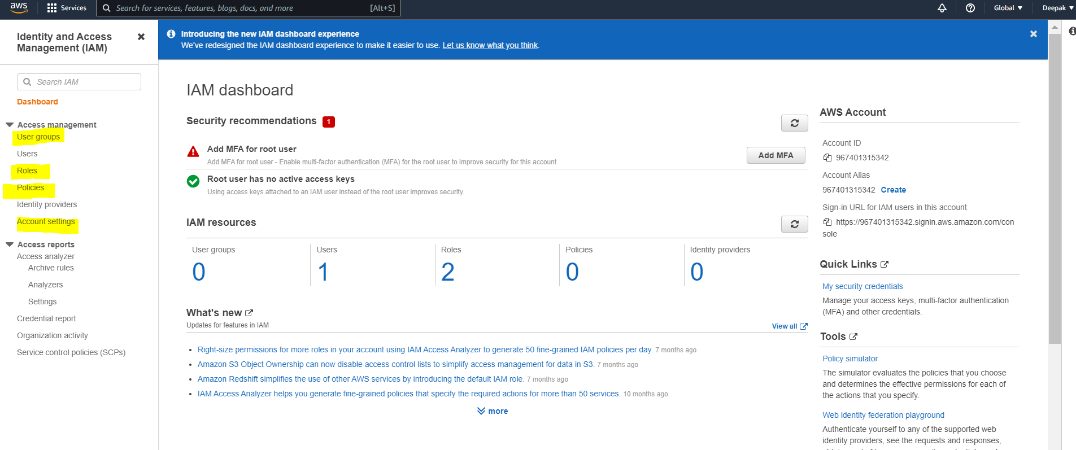  
  
2. EC2 Virtual Server:  
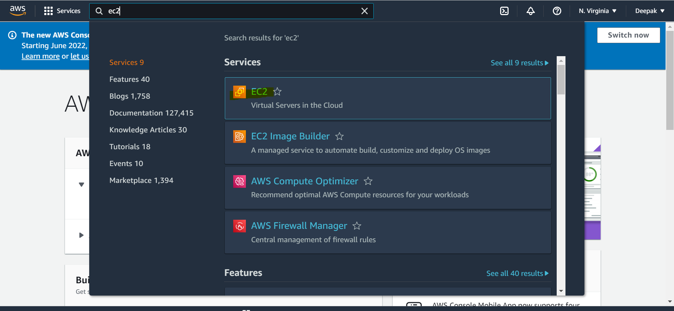  
If you change the region then resources changes too.  
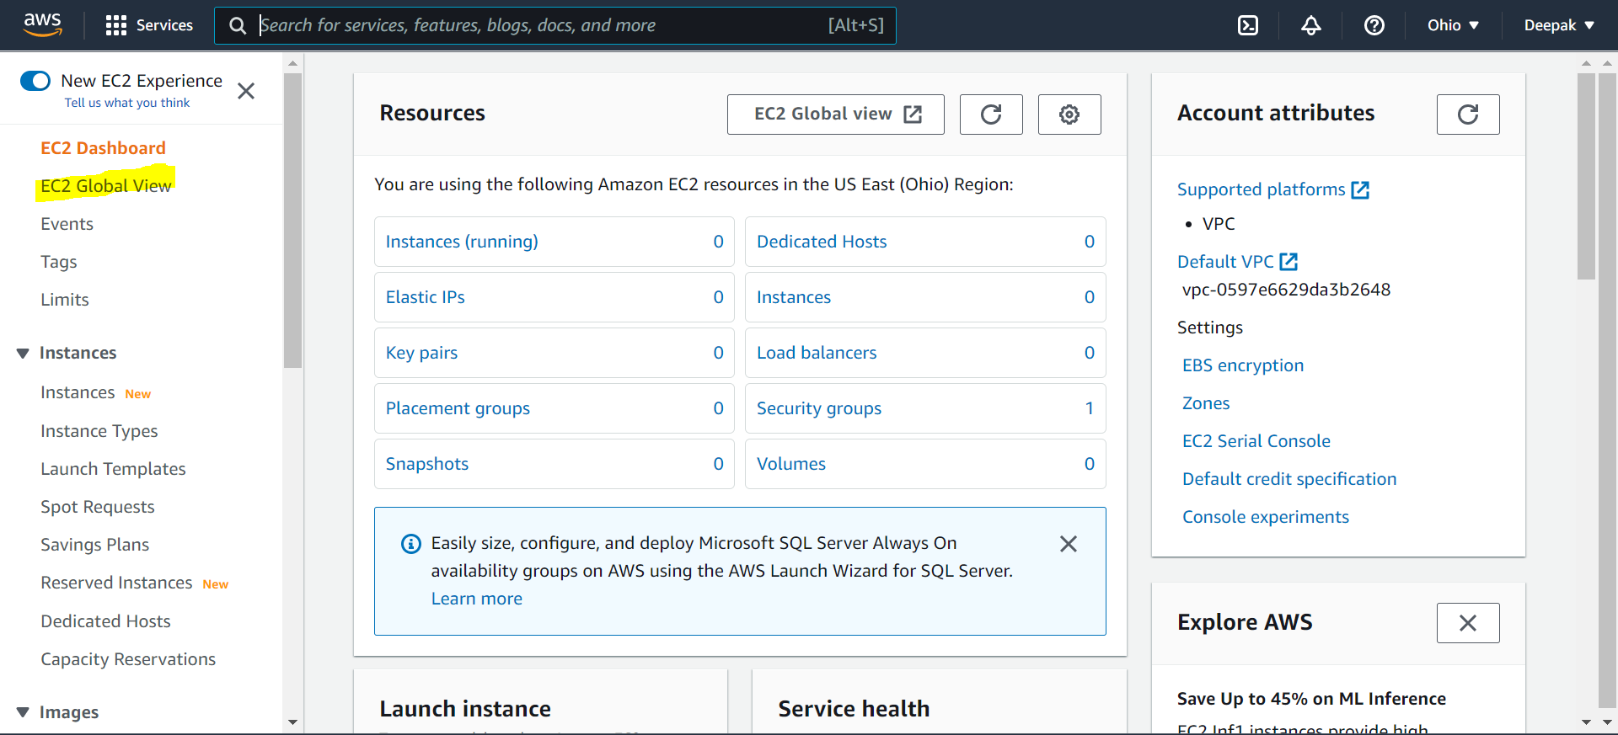

If you create an instance and forgot which region you created and which instance is there then you can use EC2 Global View.  
  
There are three instance state   
Running – Instance is running in your aws account

Terminated –permanently removed from aws account  
Stopped – Instance is stopped  
  
create new instance (Server creation)  
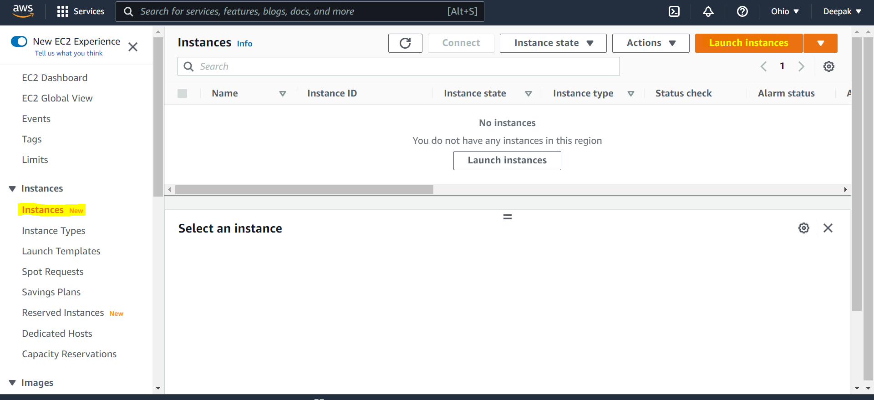  
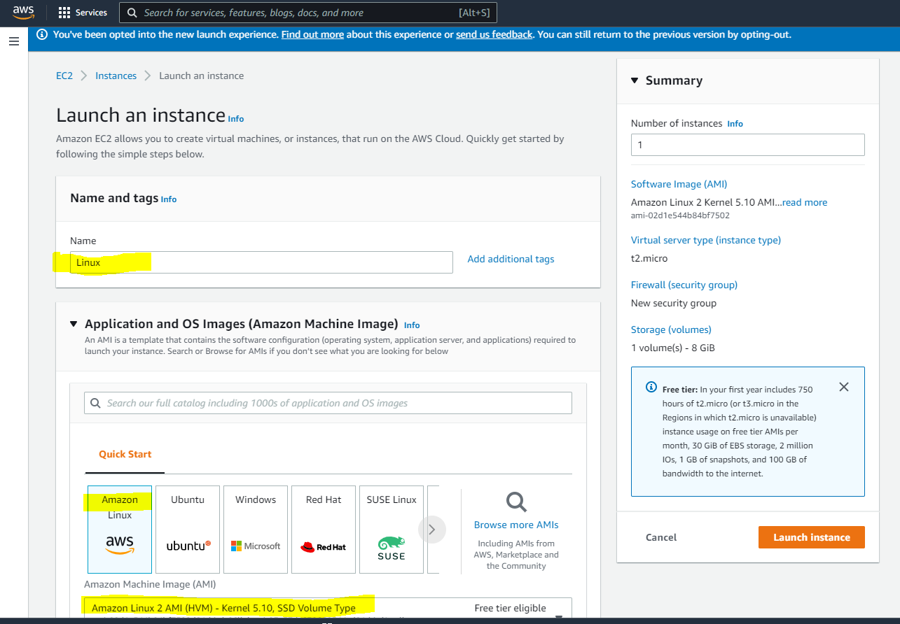  
  
Application and OS Images (Amazon Machine Image) Info

An AMI is a template that contains the software configuration (operating system, application server, and applications) required to launch your instance. Search or Browse for AMIs if you don’t see what you are looking for below

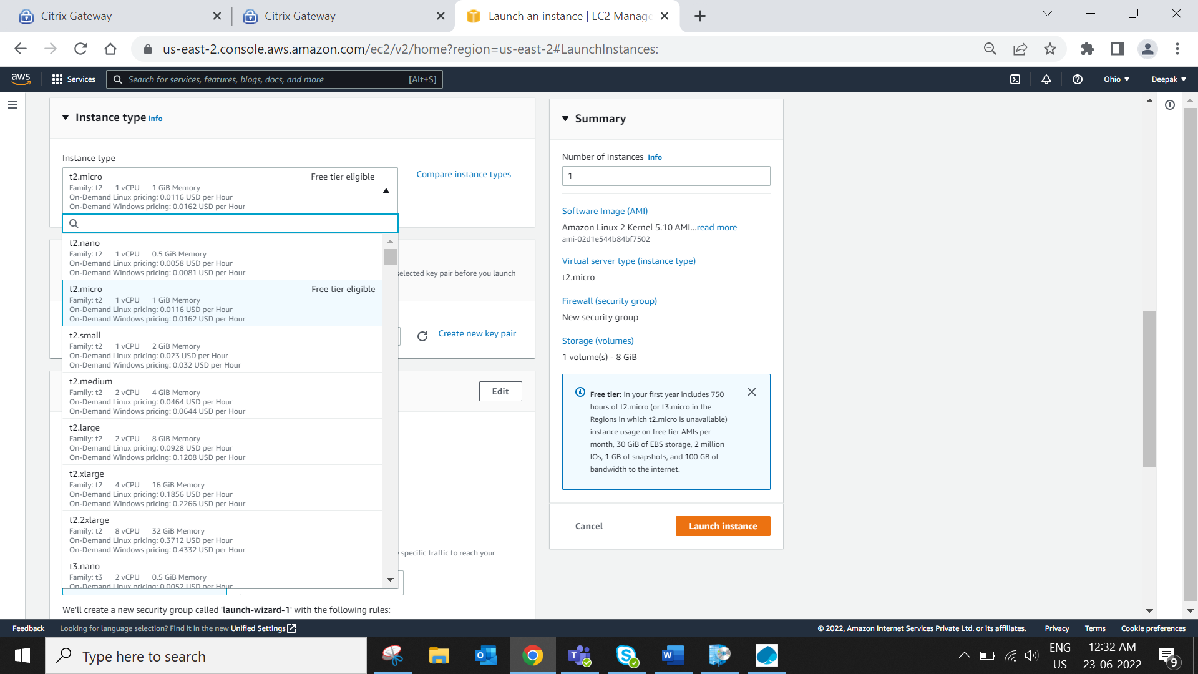  
Based on your requirement change any of the instance type  
  
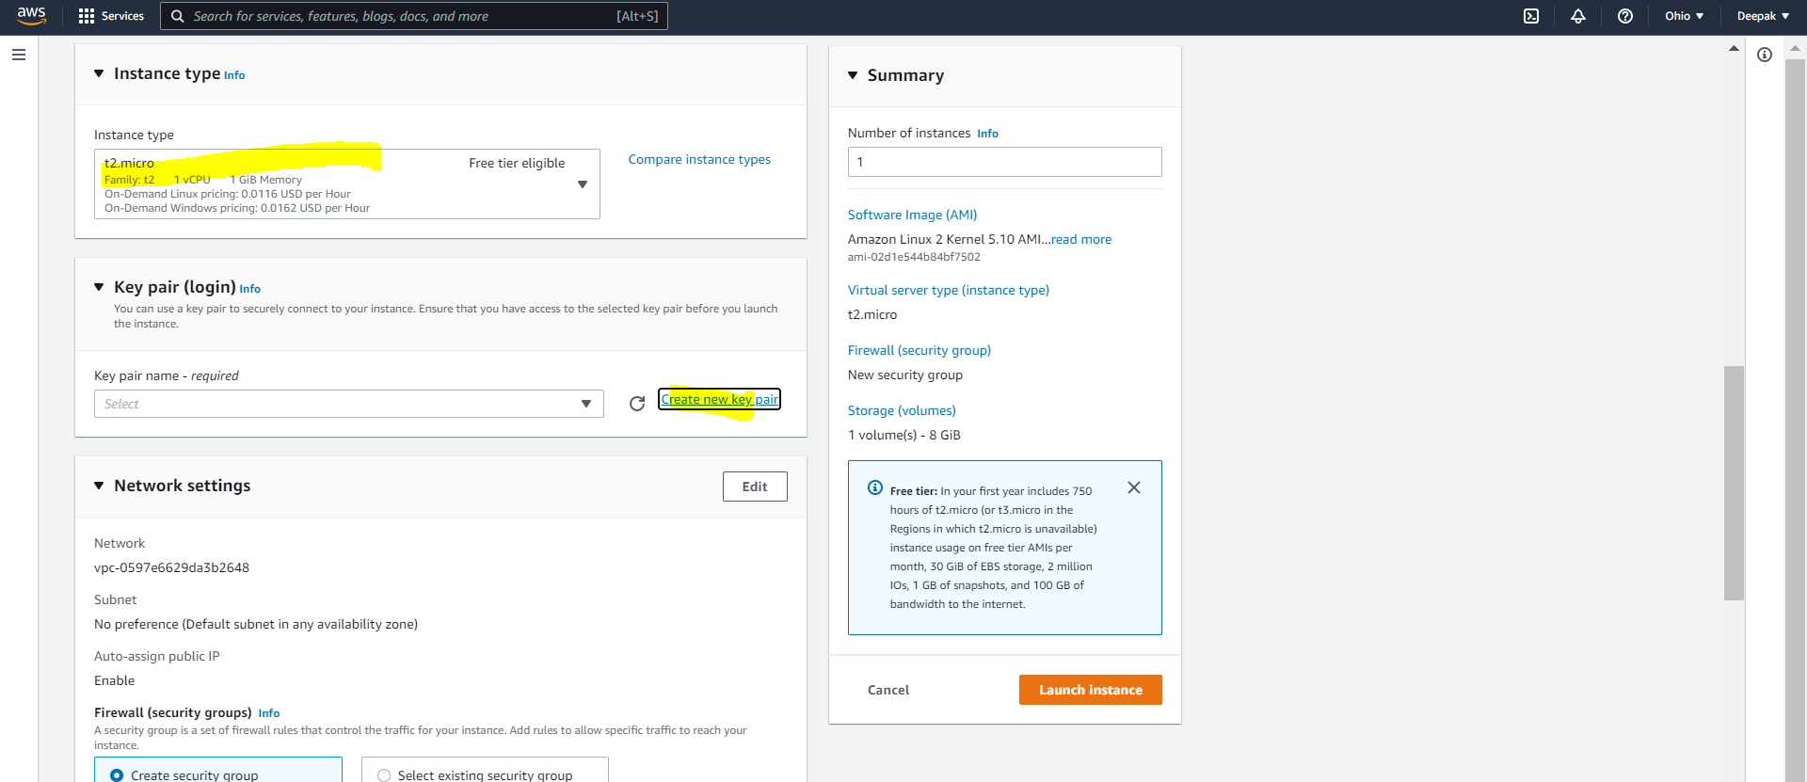  
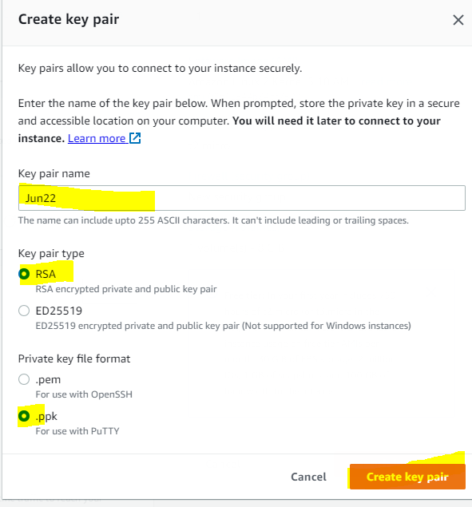 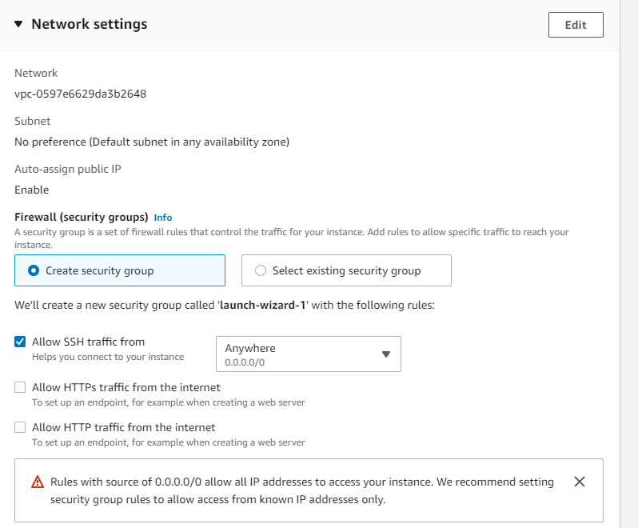  
Keep these as it is.  
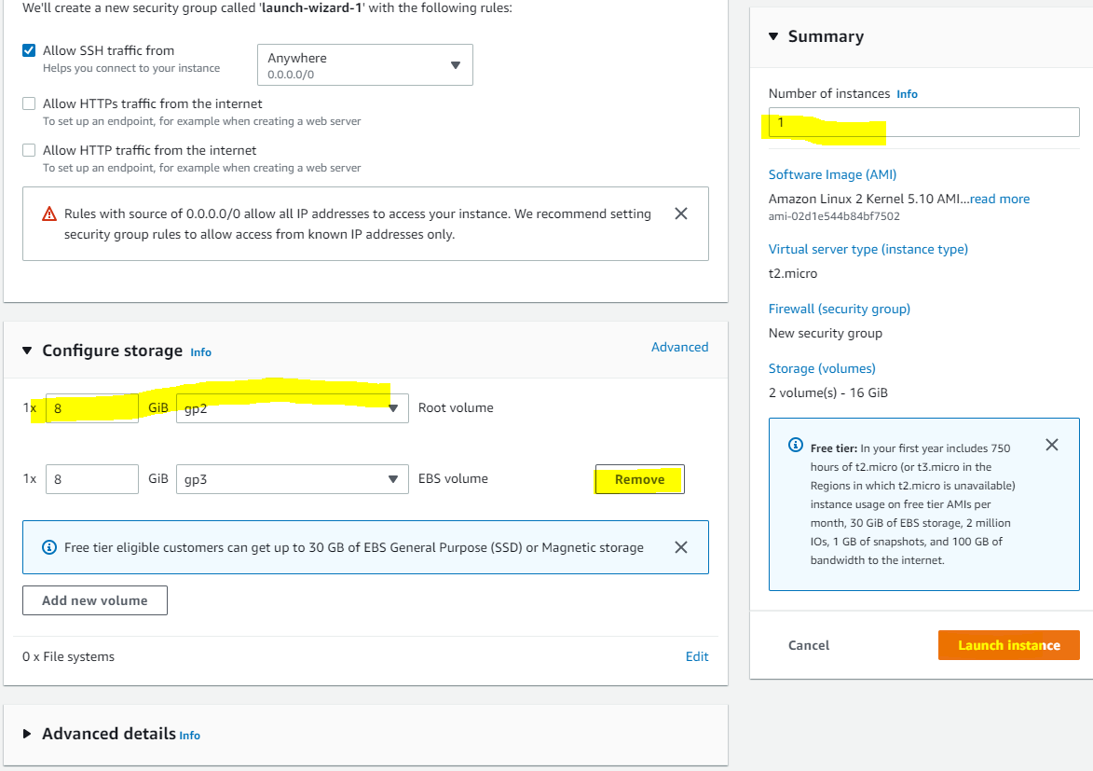  
Root Volume is permanent RAM but EBS volume is a network based RAM for now its not required.

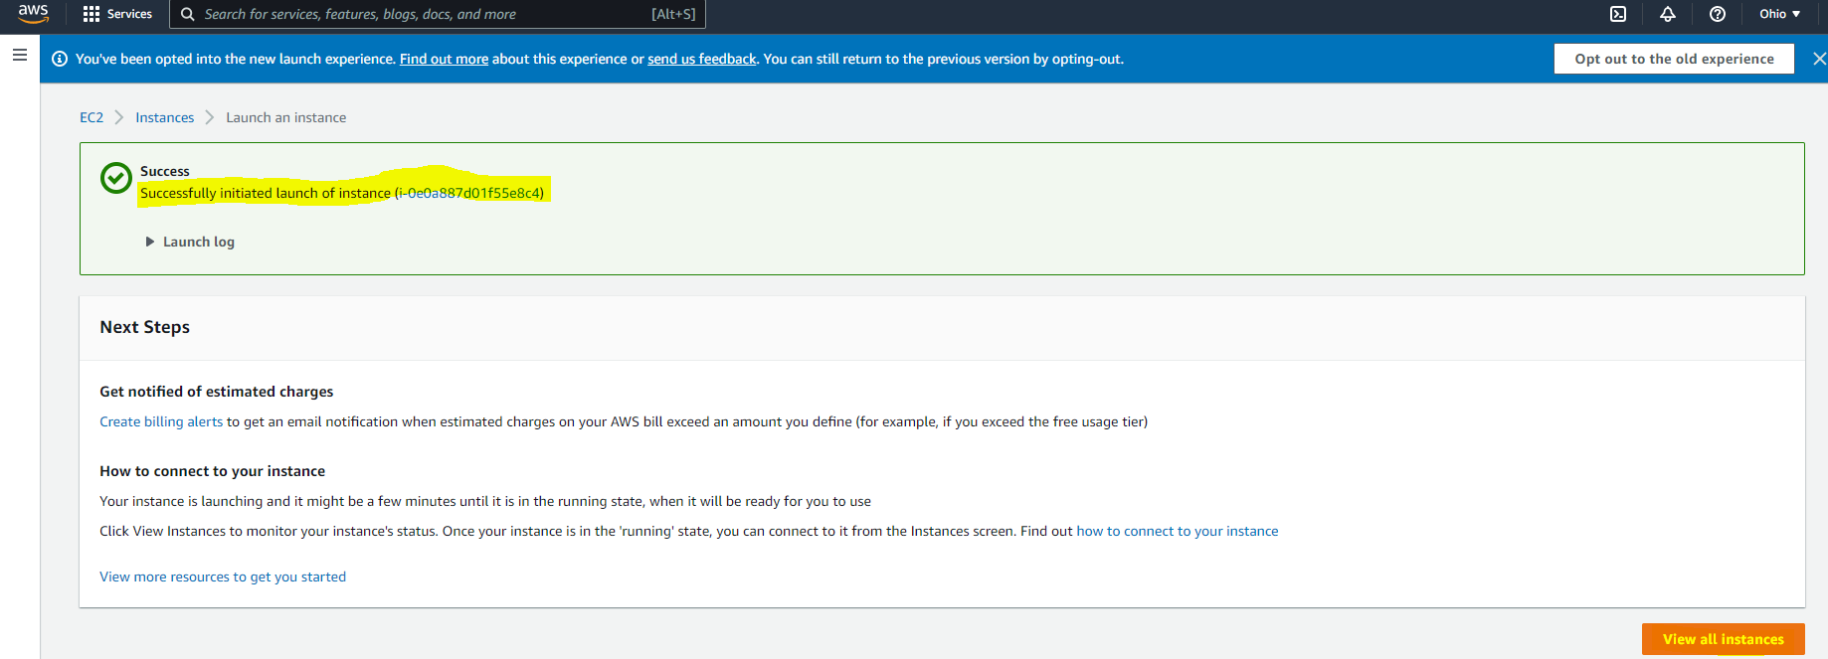  
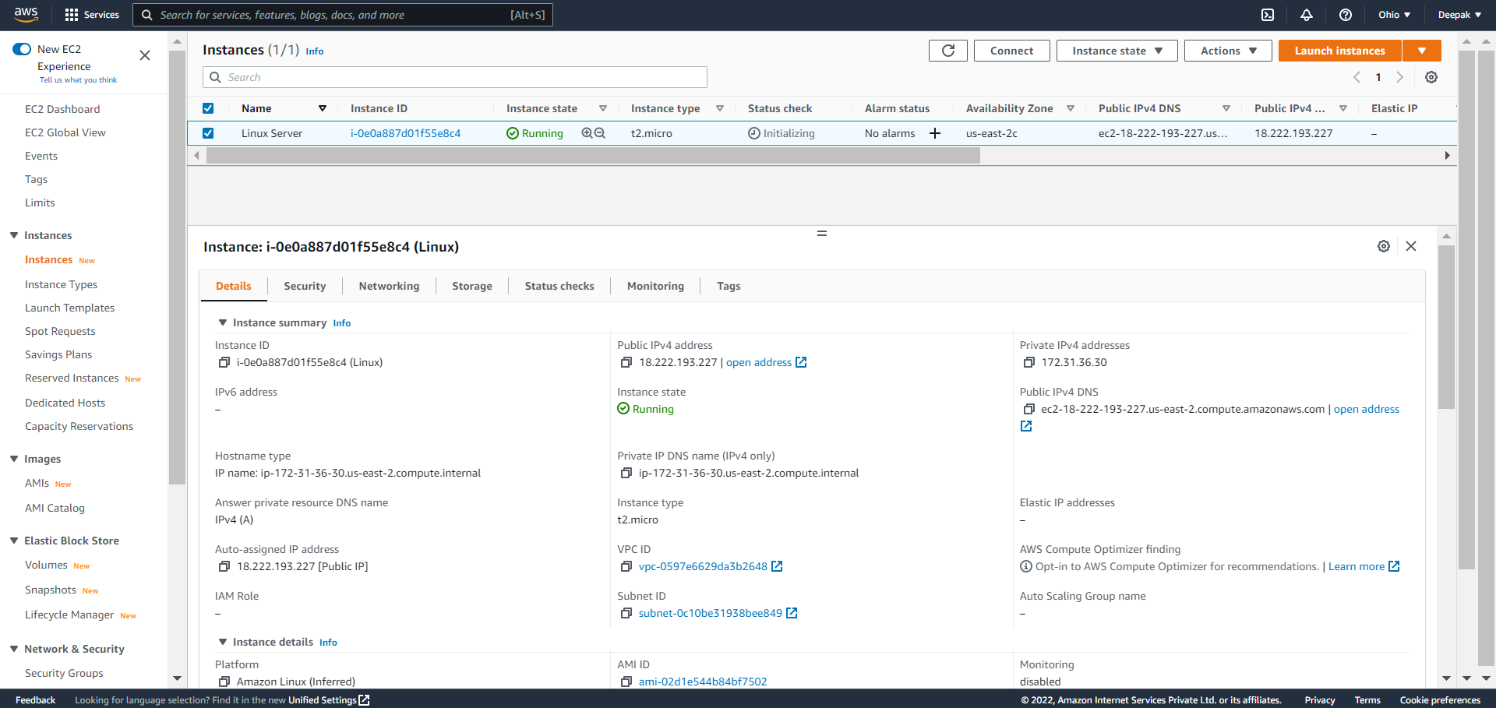  
  
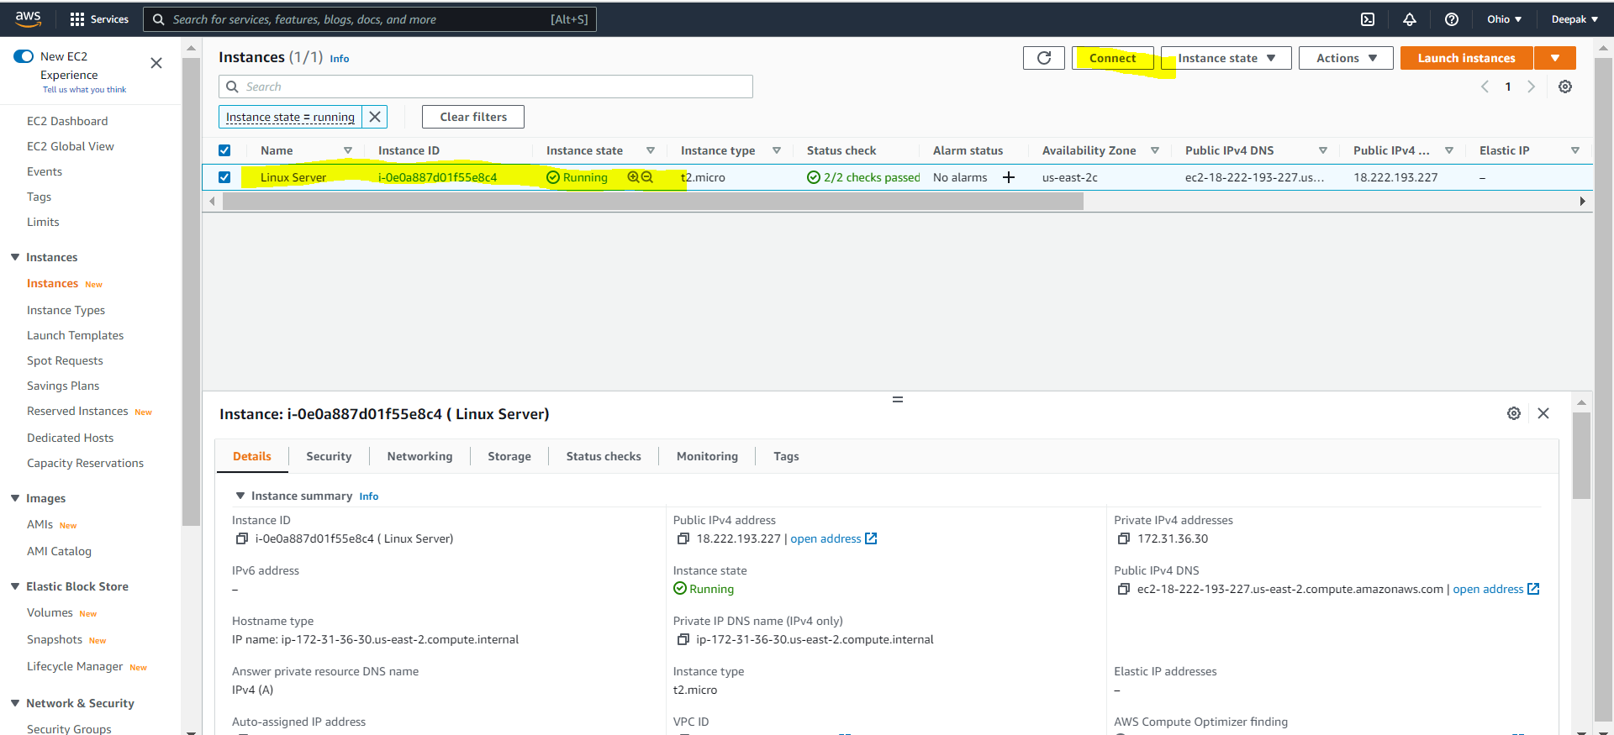

Now there are four approach to run

1. EC2 Instance connect  
   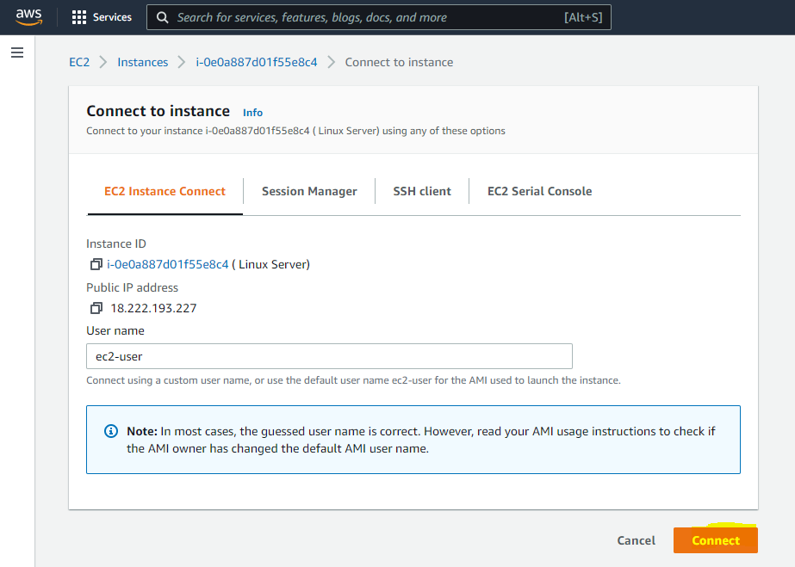 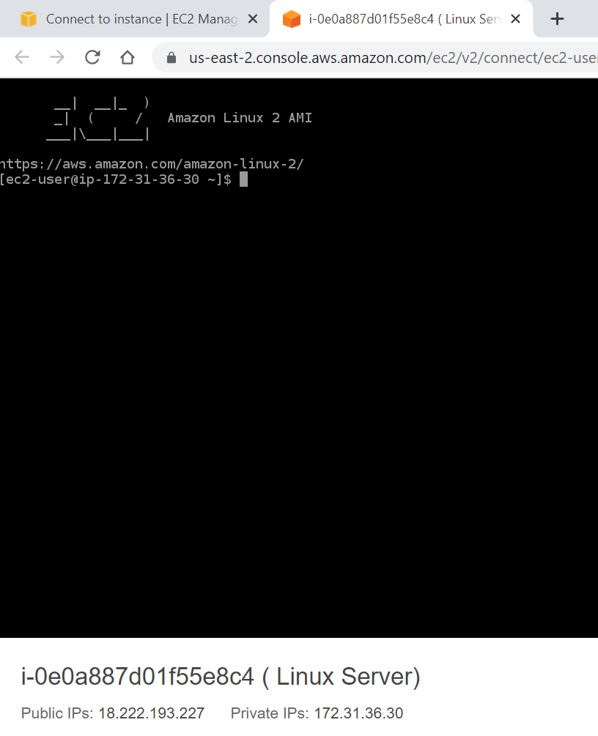
2. SSH Client:

Putty and AWS CLI need to install

a. Install AWS CLI: (Download from your system browser and install)  
To check its working or not  
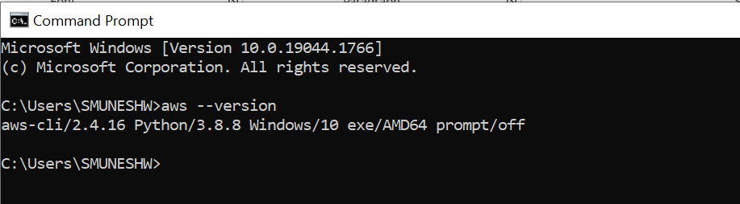

b. Install Putty

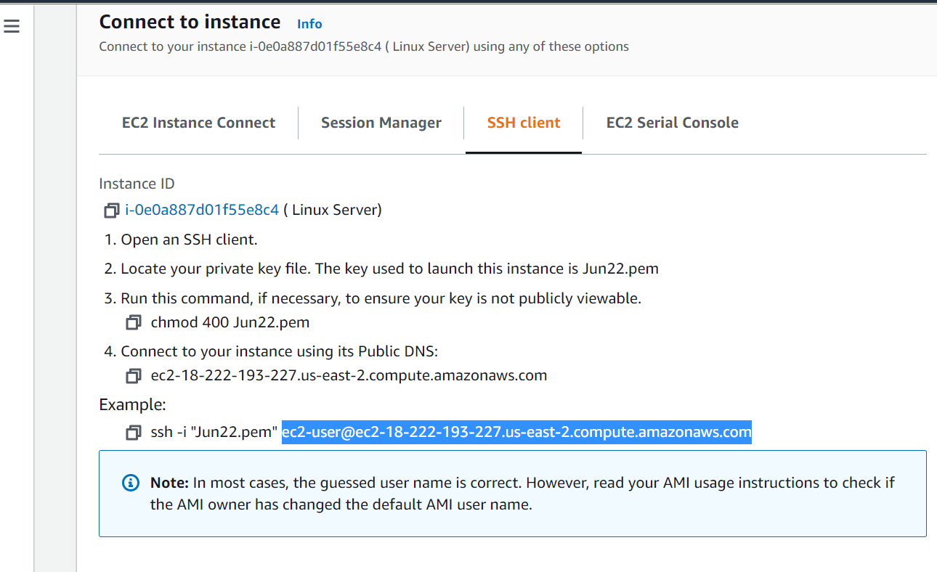 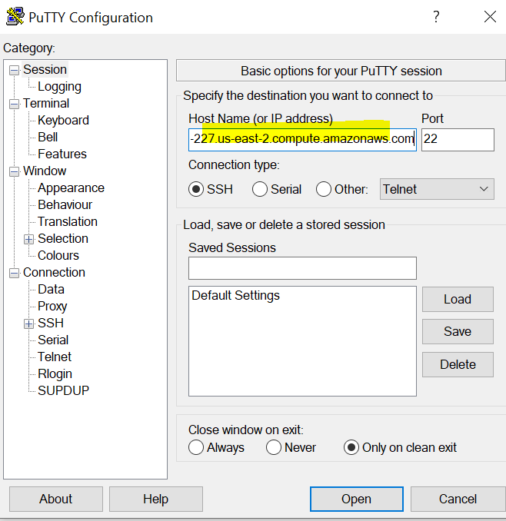  
  
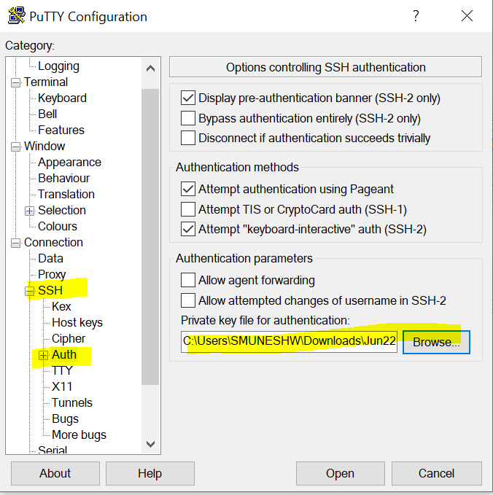 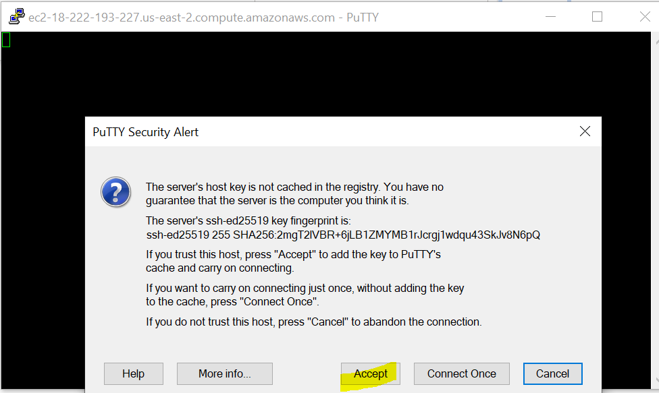  
Add the ppk file here and accept  
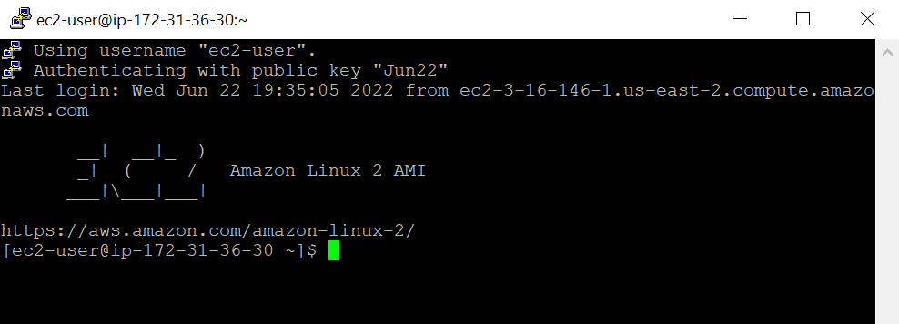  
Last step is remove the instance from your account as it take charges for using long time

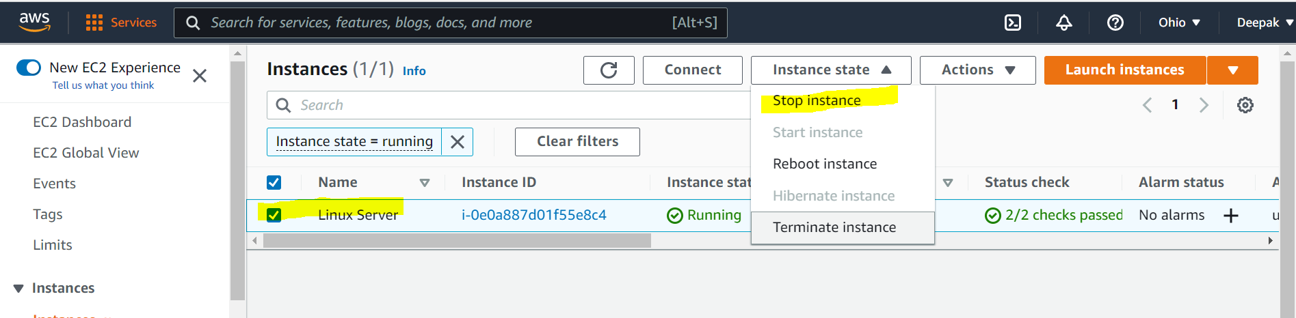  
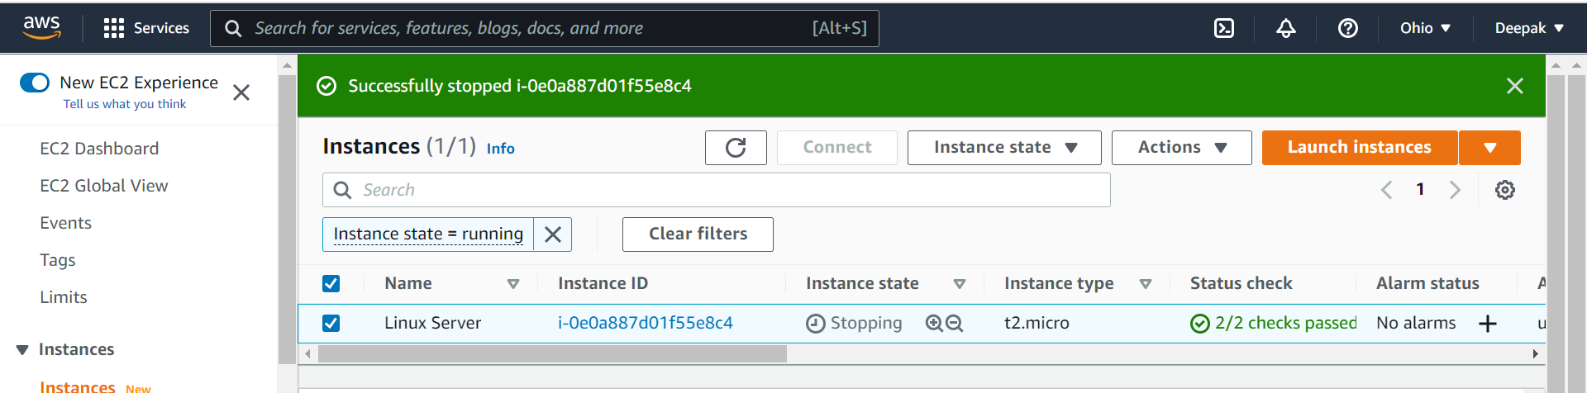  
if you don’t require the instance then you can terminate as well.

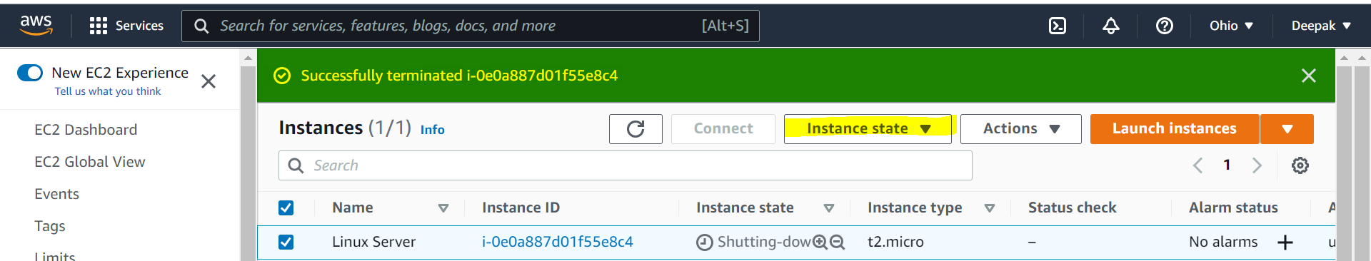

Options in the instances:

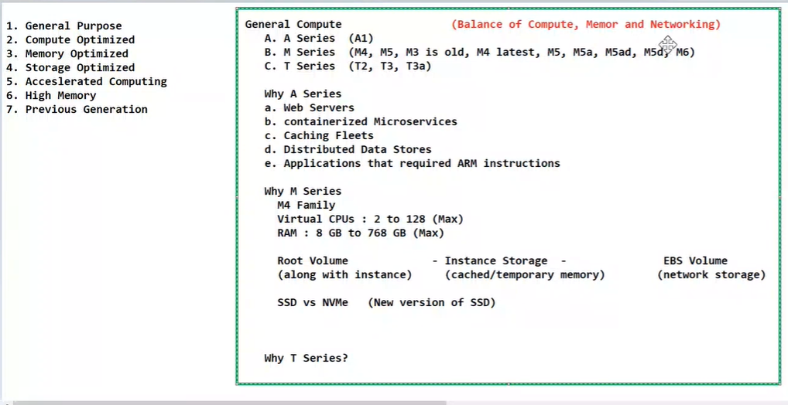  
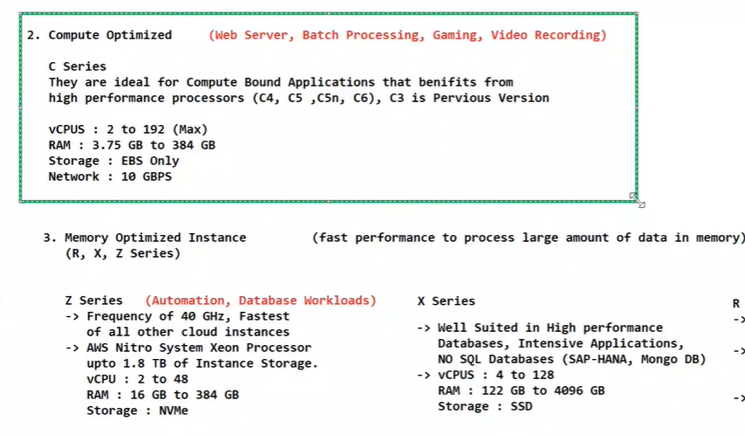  
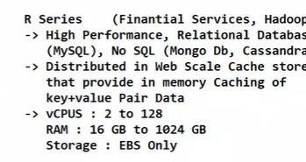

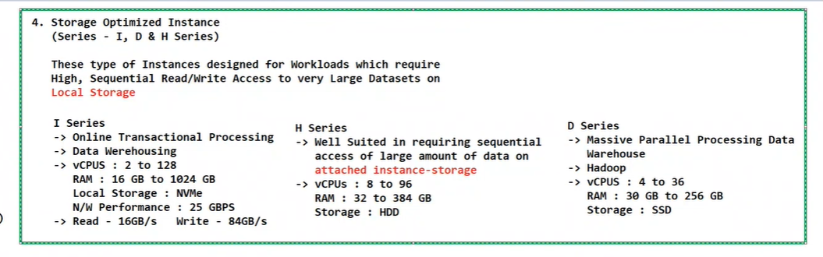

**Configure a Security Group for HTTP Access**

Your organization is migrating some of its on-premises web sites running on Linux virtual machines (VMs) to Amazon Web Services (AWS). You need to configure the access to a proof-of-concept website currently deployed on AWS.

The proof-of-concept deployment includes the following pieces:

* A VPC, virtual-private-cloud, with one public subnet called public-subnet
* An Internet gateway associated to the public subnet
* A network access control list configured to block all inbound connections
* Amazon Linux EC2 instance, named ec2-web, started in the public subnet

Log into the AWS Management Console and complete the following steps:

1. Open the **Services** menu in the top navigation bar and select **EC2** from the **Compute** category.
2. From the **Resources** list, select **Security groups** and click **Create security group**.
3. On the **Create security group** page, begin creating a new security group by entering the following information under basic details:
   * Security group name: Enter pub-ec2-sg
   * Description: Enter Allow public HTTP access to EC2 instances
   * VPC: Choose **virtual-private-cloud** from the dropdown menu
4. Under **Inbound rules**, click **Add rule** to create an inbound rule with the following information:
   * Type: Choose **HTTP** from the dropdown menu
   * Source type: Choose **Anywhere** from the dropdown menu
   * Description: Enter Allow HTTP inbound from Internet
5. Click **Add new tag** and enter a **key** of Name, a **value** of pub-ec2-sg, and click **Create security group** to complete the process.
6. To associate our new security group with our EC2 instances, click **Instances** in the navigation pane.
7. Select **ec2-web** from the instance list, open the **Actions** menu, and click **Security > Change security groups**.
8. Under **Associated security groups**, select **pub-ec2-sg** and click **Add security group**.
9. From the listing, click **Remove** after the **default** security group and click **Save**.
10. Under the instance properties, select the **Security** tab and verify that only **pub-ec2-sg** is listed under Security groups. This verifies only the new security group will be applied.
11. Click the **Details** tab for the instance, copy the **Public IPv4 DNS** value listed (click the two square icon to the left of the name), and paste the value into a browser window.

After a few moments, you will receive an error of connection timed out. This verifies that your website is not publicly available. Keep this window open for the next challenge.

# Troubleshoot HTTP Access to the EC2 Instance

You suspect the HTTP connectivity problem lies with the network access control list associated with your instance’s VPC. You will check the network access control list and make changes needed to allow HTTP traffic to your website.

From the AWS Management Console, complete the following steps:

1. From the Services list, select VPC under Networking & Content Delivery.
2. From the VPC Dashboard navigation menu, select Subnets.
3. Select the public-subnet subnet, and browse to the Network ACL tab.

After selecting the tab, you’ll see an access control rule (10) that blocks all inbound traffic to your instance’s subnet. You need to remove that inbound rule.

1. From the navigation menu, select Network ACLs.
2. Ensure the network-ACL is selected, and choose the Inbound Rules tab. You will see rule that is set to Deny all HTTP traffic, Rule 10. This is the rule that needs to be removed.
3. On the Inbound Rules tab, Click Edit inbound rules.
4. On the **Edit inbound rules** page, delete rule 10 by clicking the X icon on the row’s right side and click **Save**. The deny rule will no longer be listed under the inbound rules.
5. To re-test website access, open the Services menu and browse to the EC2 dashboard.
6. From the navigation pane, choose Instances and select ec2-web from the list. This will open the Details tab for the instance.
7. From the Details tab, copy the Public IPv4 DNS value listed (click the two square icon to the left of the name) and paste the value into a browser window.

In the web browser window, a message will be displayed similar to Running on ec2-web-a | Instance-id i-XX where XX is the instance id for the EC2 instance.

Congratulations! You have successfully configured a security group for an EC2 instance, and you configured network access control rules for traffic into a VPC and it’s associated subnets.. While this example focused on HTTP traffic, the principles can be applied to any traffic you would need to allow such as SSH for host management.

﻿

**Basics of networking**

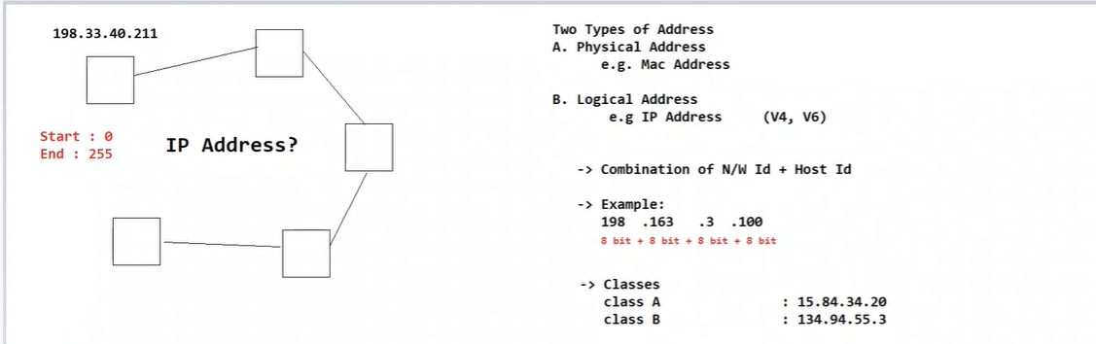

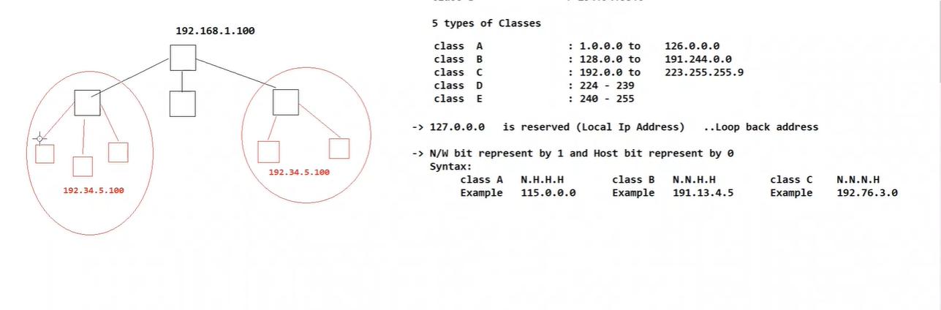

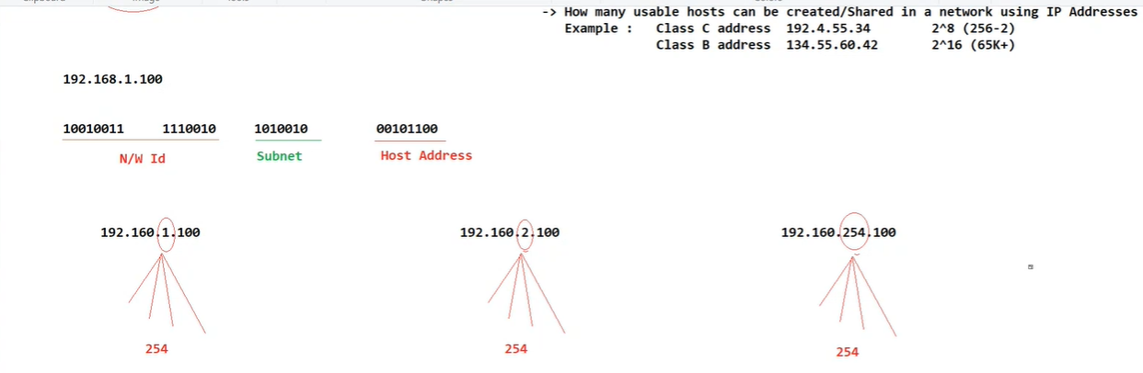

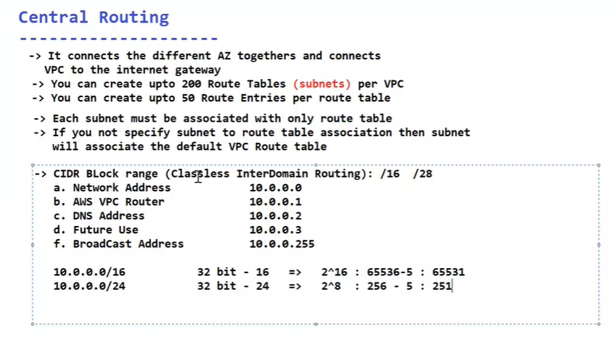  
lab : <https://app.pluralsight.com/labs/detail/f36b9f01-8615-49e0-a2b4-45087bb01b45/toc>

Block Storage :

Same as Linux create Ec2 instance for windows it’s the same practical

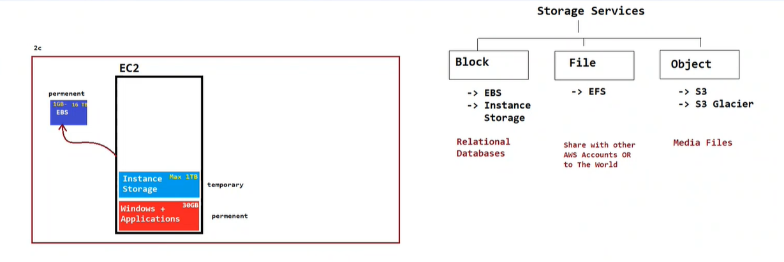

EFS:  
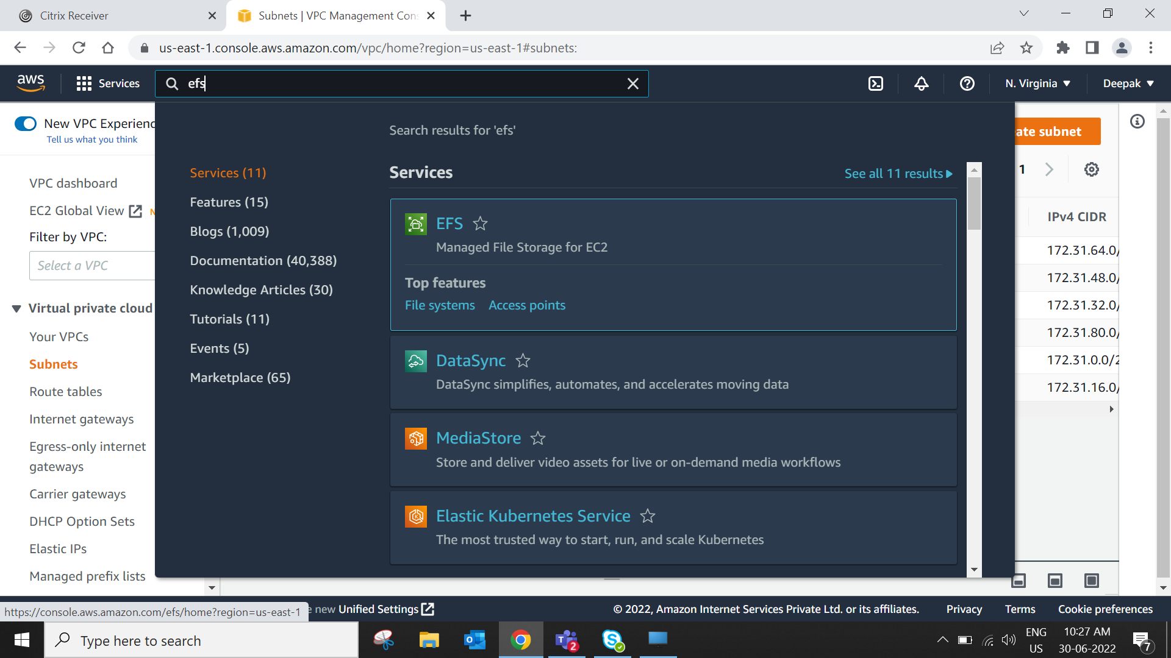  
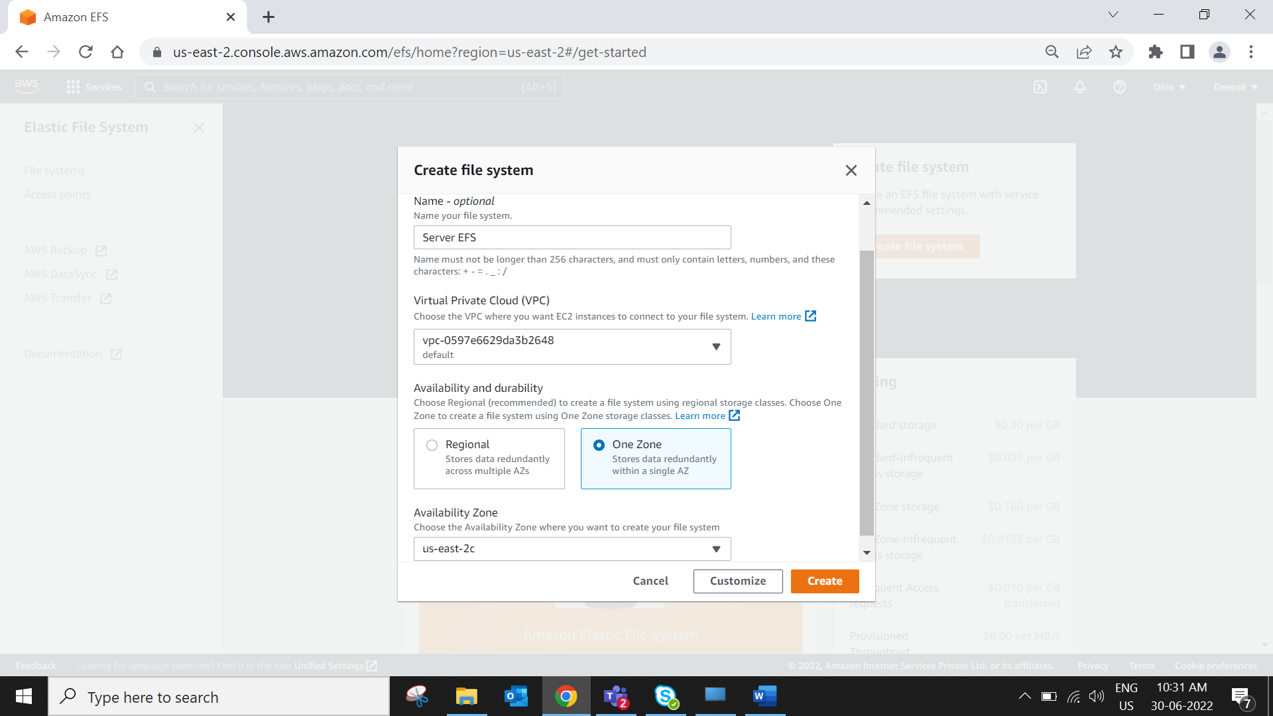  
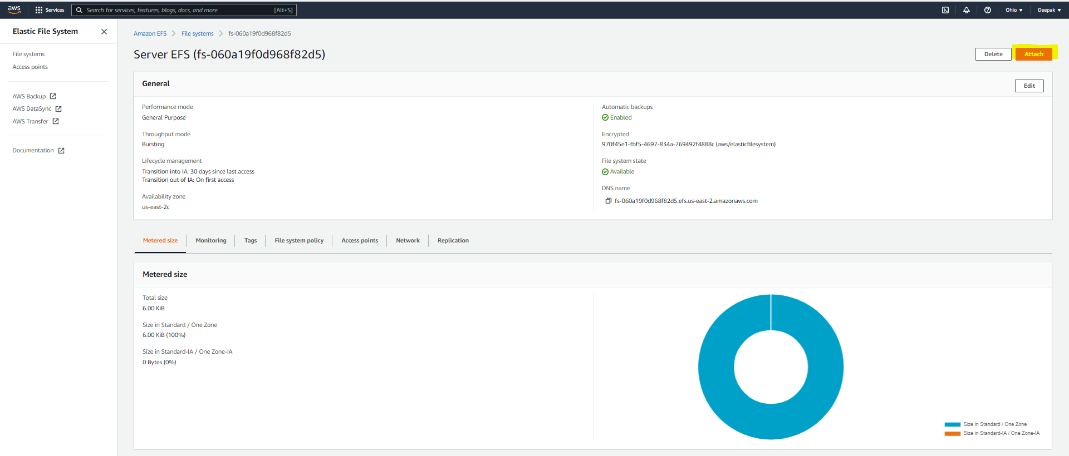  
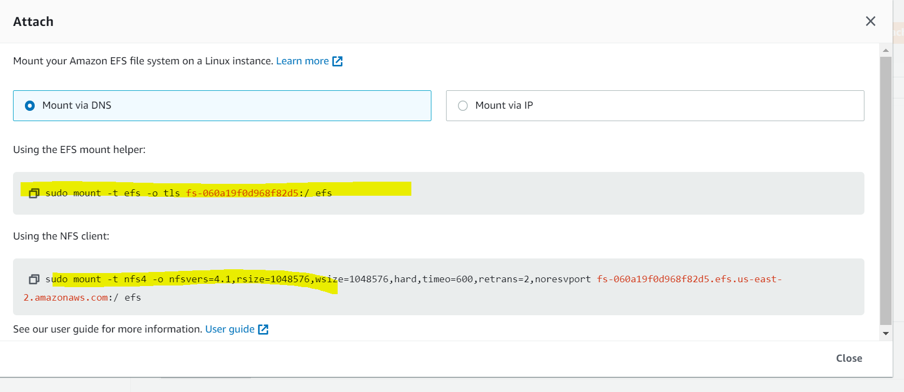  
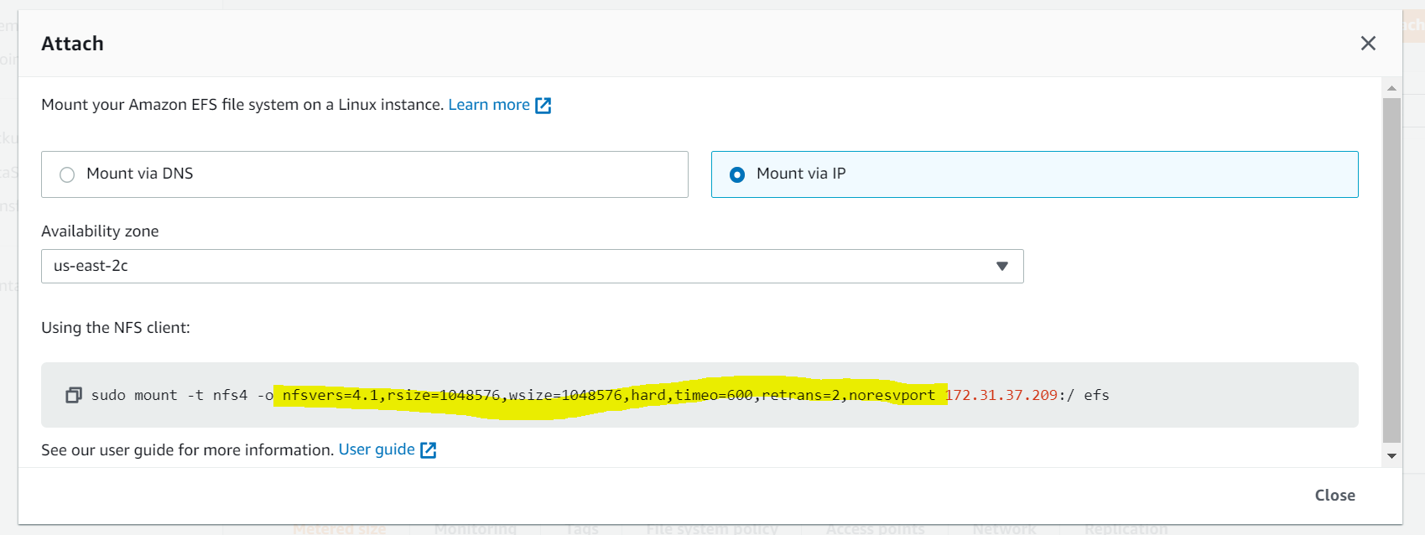

Access aws console through CLI  
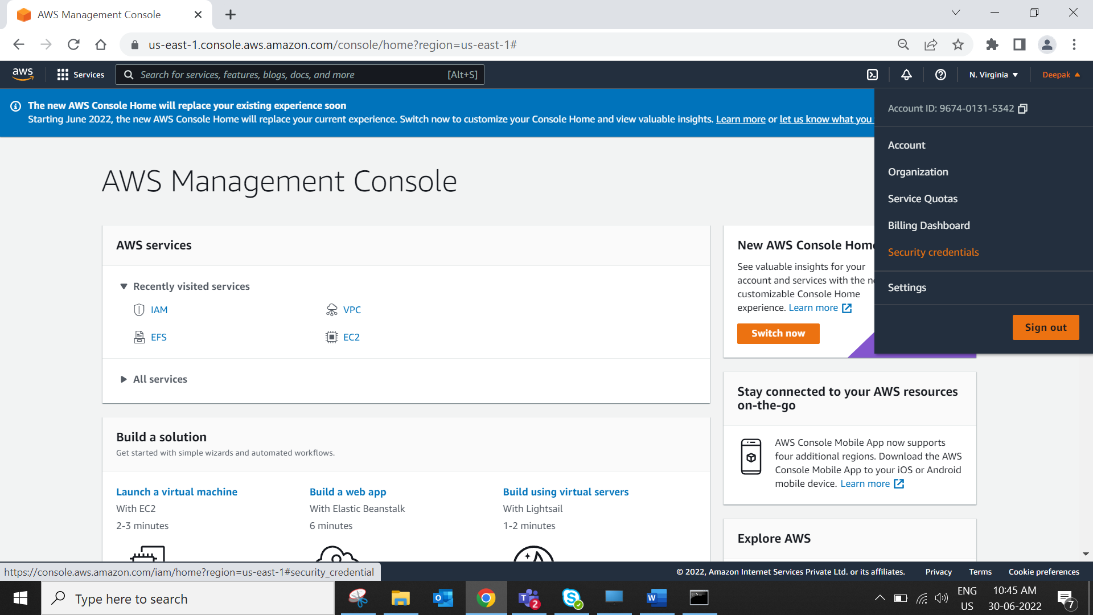  
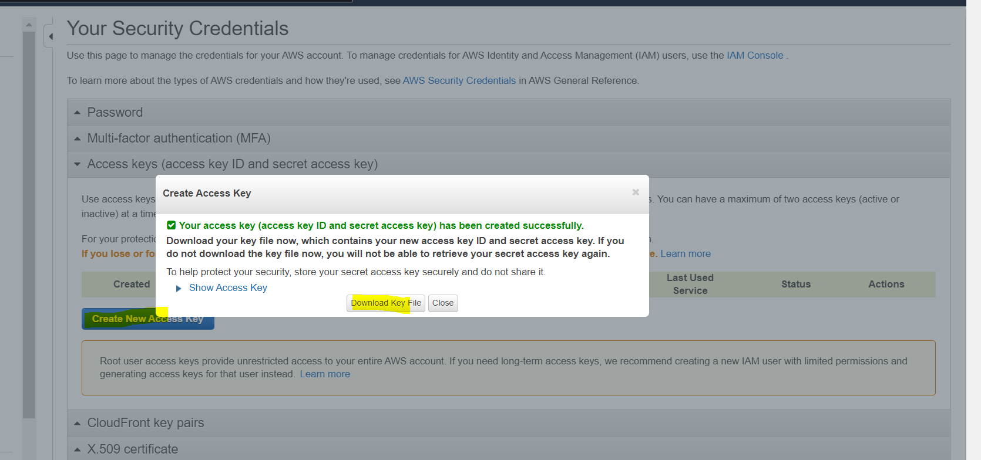

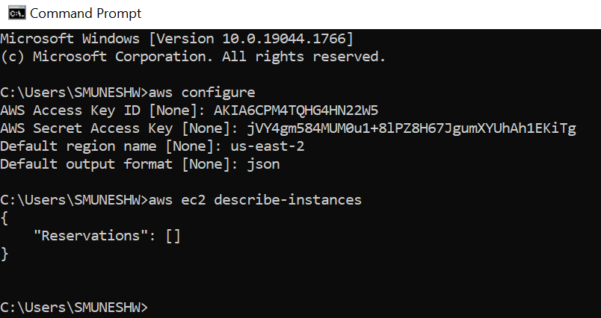  
Reservation is empty bcoz I had deleted everything and not configure much more things.

To start an instance on EC2  
cmd>aws ec2 start-instances --instance-ids i-080fe2d5fb7bfd63c  
To Stop  
cmd>aws ec2 stop-instances --instance-ids i-080fe2d5fb7bfd63c

https://www.geeksforgeeks.org/launching-an-ec2-instance-using-aws-cli/

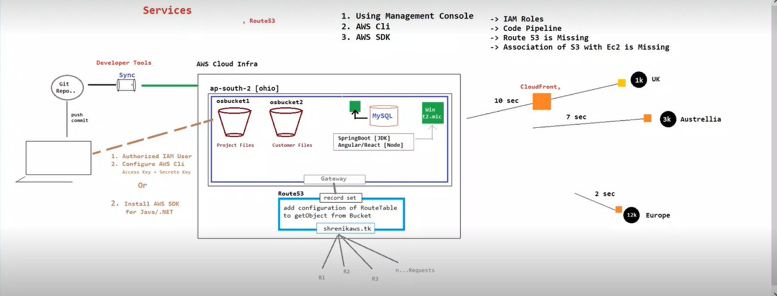  
RDS – database connection mysql   
EC2  
S3  
